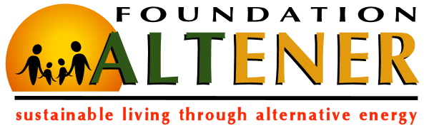

PRESENT US YOUR PROJECT!
An elaborate project description helps foundation ALTENER to determine the feasibility of projects. Please provide us with following information.

Your Organization
1. Name

2. Type of organization

3. Mission & vision

4. Main activities

Project Description
1. Goal of the project

2. How is your project related to renewable energy?

3. Who will benefit from the project?

4. Why is your project important?

5. How will your organization be involved in the project?

6. What is the estimated cost of the project?

7. How do you want to finance the project (budget, sponsors, partners, governmental programs)?

Project’s Future
1. What impact will your project have for your community?

2. Will your project have any continuation in the future?

Thank you for taking your time! Please send the filled in questionnaire to info@altener.org.

